**Power Law Transformation**

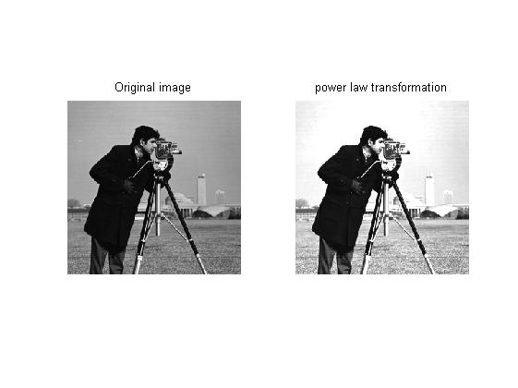c=1.5,gamma=1

* Image is transformed by transformation function:

b=c*a^gamma

where

c and gamma are constant deciding contrast enhancement

a is every pixel of original image

b is pixel of output image

* Like log transformation, increasing c and keeping gamma same gets values closer to 255 ie white.
* Varying gamma, by keeping c=1 we observed the below:

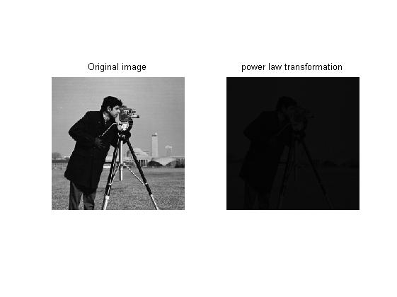gamma=0.2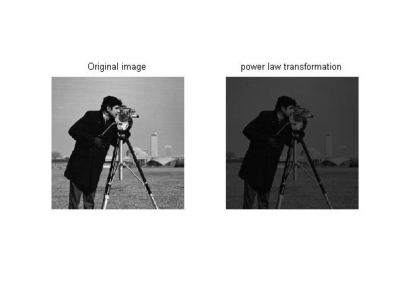gamma=0.5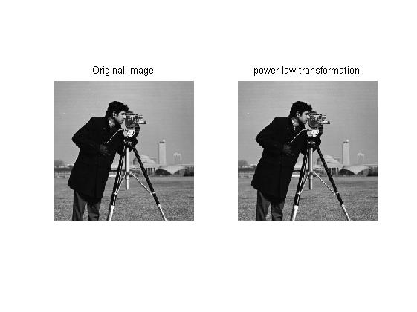gamma=1

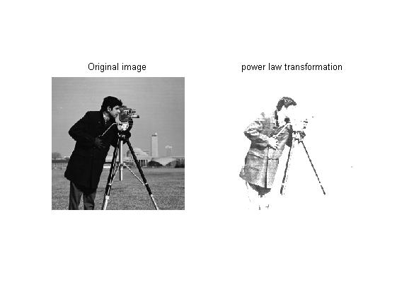gamma=2